# **Database Architecture**

The database that will store the JSON data provided in **backend/raw_data** will be a PostgreSQL schema called **app** with 5 tables.

**Diagram showing the relational model between the 5 tables of the database schema.**

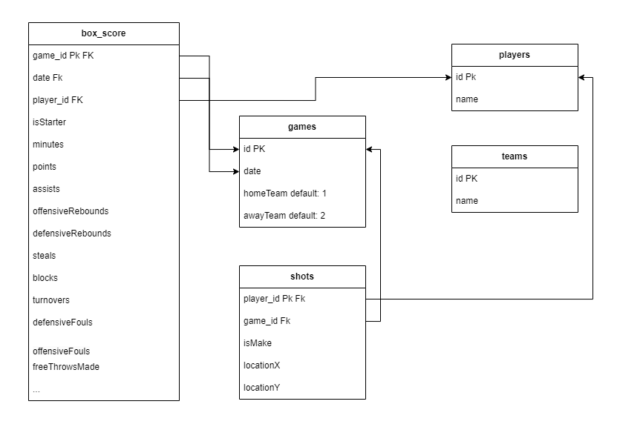

Referring to the diagram above, some of these tables require the pre-existence of other tables for data to be inserted into them. The relational model for the tables of the **raw_data** schema is defined as follows:

* The **games** table has 4 columns. Its primary key is **id**. This table is meant to store all the key/value pairs from **/raw_data/games.json** excluding keys that store arrays as values.
* The **players** table has 2 columns and a primary key called **id**. It is meant to store the key/value pairs from **/raw_data/players.json**.
* The **box_score** table has 22 columns. Its primary key is the **id** field. The script found in **backend/raw_data/scripts** will insert the JSON data from **backend/raw_data/games.json** by accessing the key/value pairs under the ‘**players’** property of each object. This table has a **player_id** field which is a foreign key.
* The **shots** table has 7 columns, its primary key is the **id** field. It has a **player_id** column – a foreign key that is dependent on the **players** tables primary key called **id**. This table will store the key/value pairs in **/raw_data/games.json** from the **shots** property under the ‘**players’** key.
* The table called **teams** is independent. It has 2 columns and a primary key of **id**. It will store the key/value pairs from **/raw_data/teams.json**.